ASSIGNMENT 13

Name : Akanksha Joshi

Roll No : B038

Batch : 3

Div : BTech CS B

1.Consider the scenario of retail store management again. The store provides discount for all bill amounts based on the criteria below:

Write a Python program to ﬁnd the net bill amount after discount. Observe the output with diﬀerent values of bill amount.

Assume that bill amount will be always greater than zero

Source Code

amount = int(input(**"Enter bill amount : "**))  
**if** amount>=1000:  
 discount = 0.05  
**elif** amount>=500 **and** amount < 1000:  
 discount = 0.02  
**elif** amount>0 **and** amount<500:  
 discount = 0.01  
  
net = amount-(discount*amount)  
print(**"net bill amount is : "**,net)

Output

1. When input is above 1000

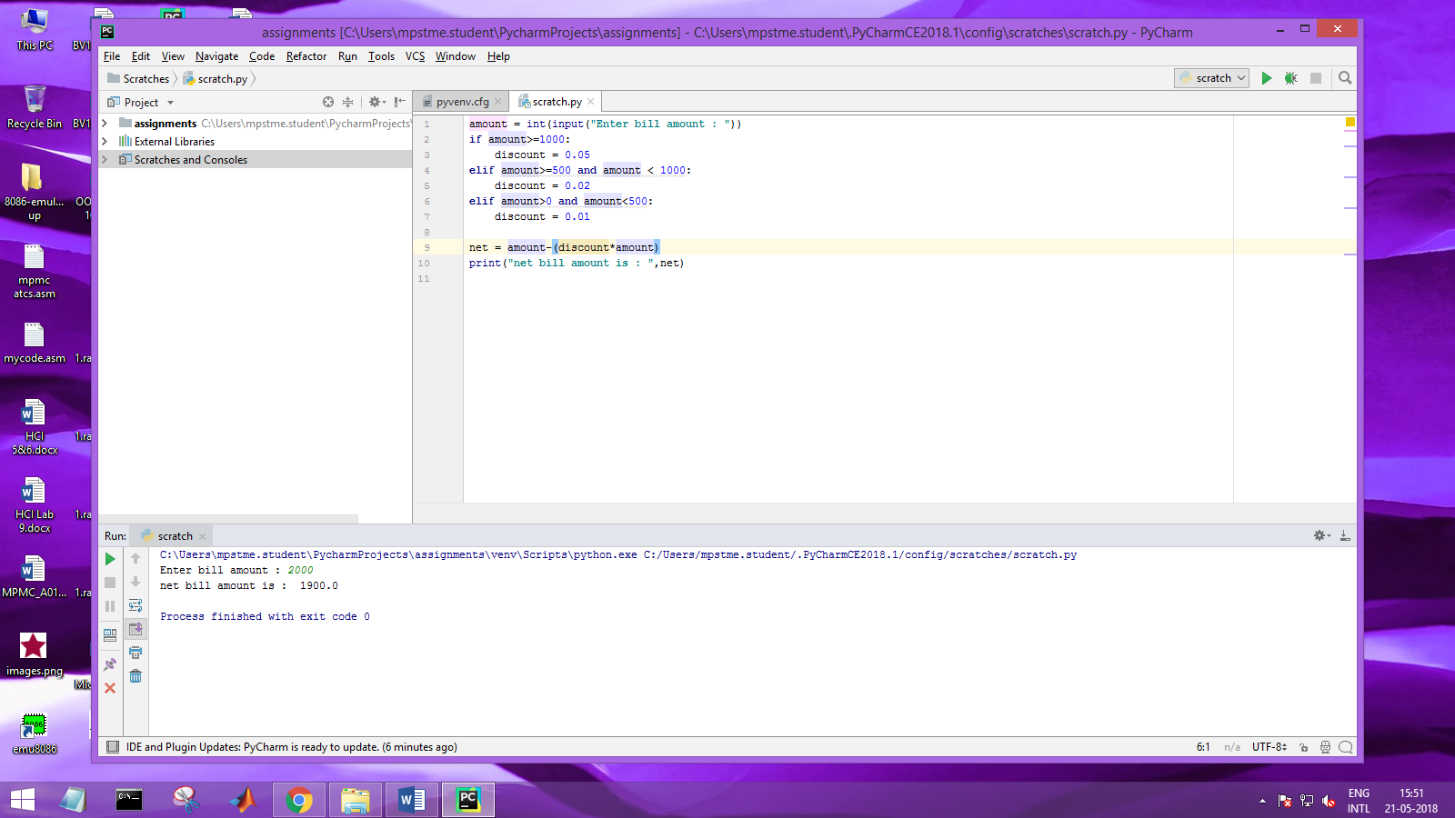

B. When input is between 500 and 1000

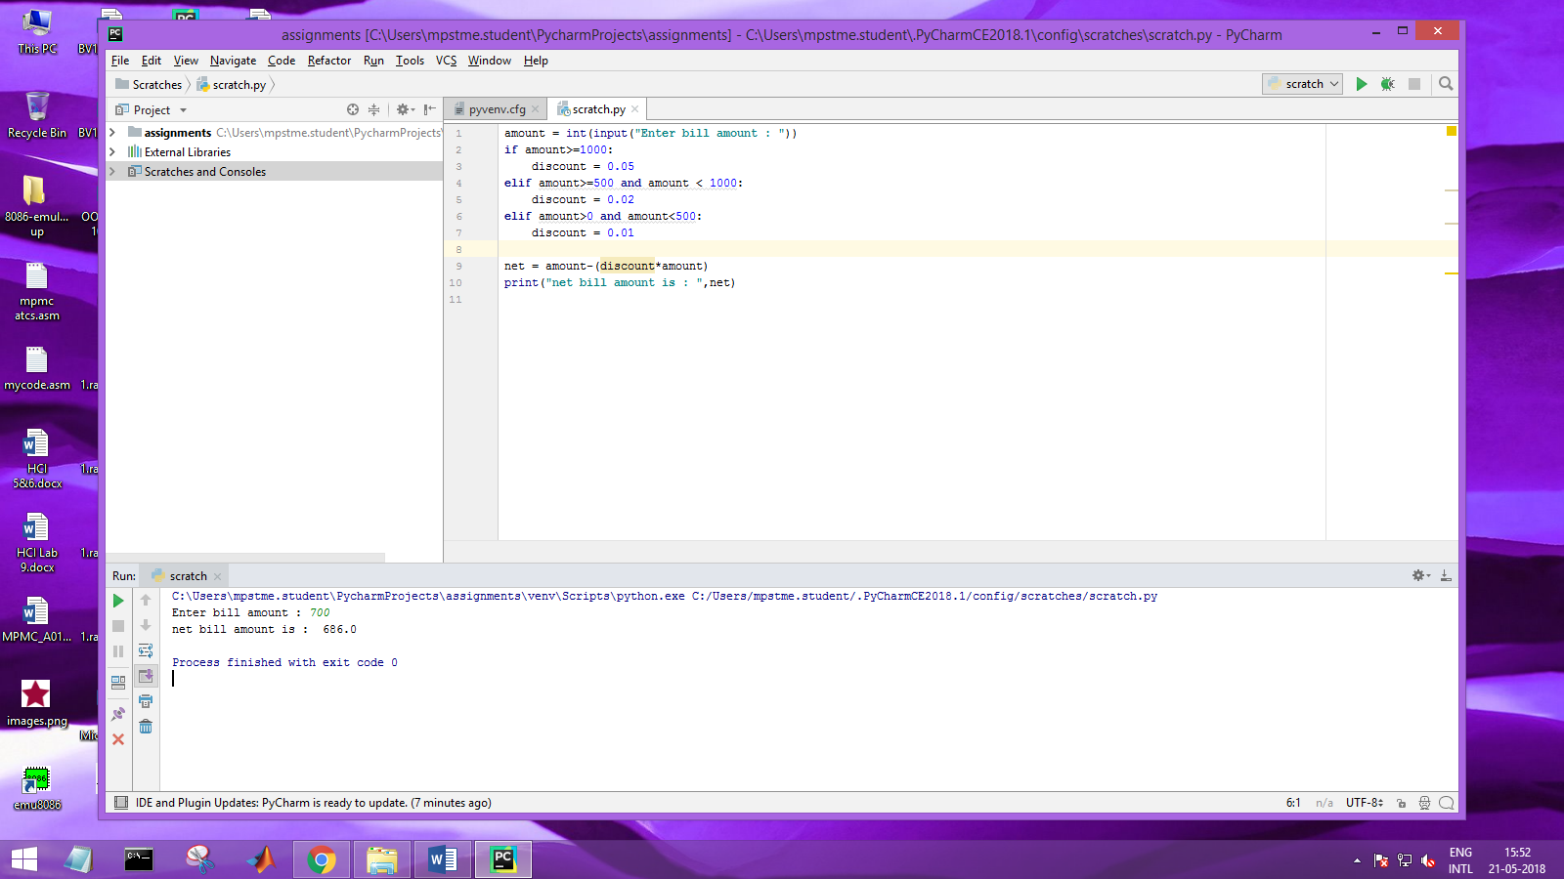

1. When input is less than 500

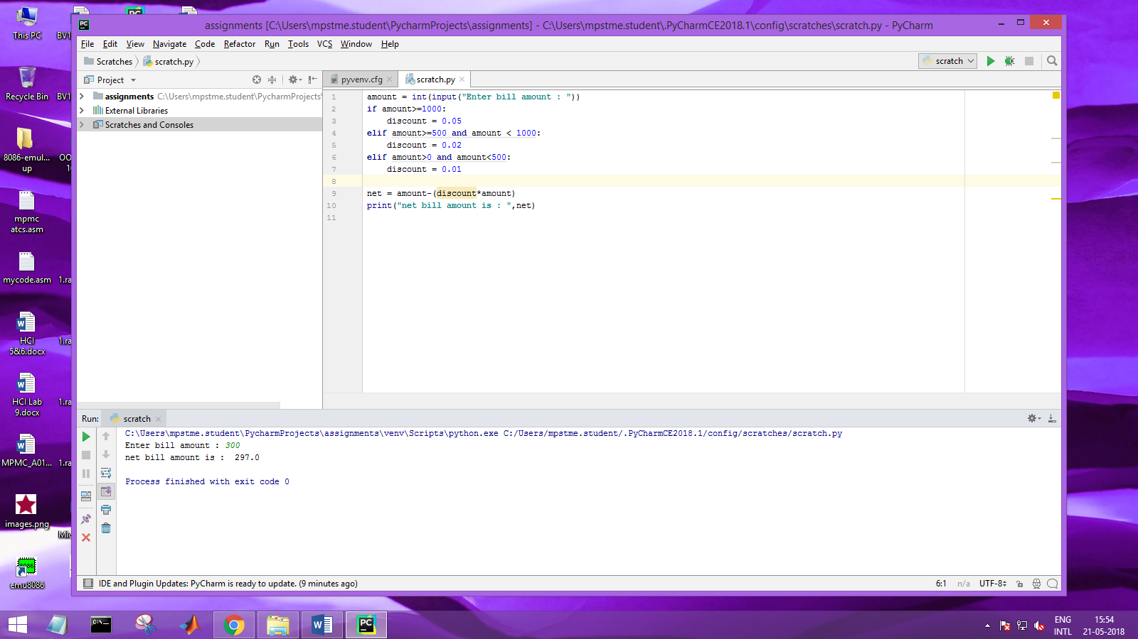

2. Extend the above program to validate the customer id. Customer ids in the range of 101 and 1000 (both inclusive) should only be considered valid.

Note: Display appropriate error messages wherever applicable.

Source Code

amount = int(input(**"Enter bill amount : "**))  
**if** amount>=1000:  
 discount = 0.05  
**elif** amount>=500 **and** amount < 1000:  
 discount = 0.02  
**elif** amount>0 **and** amount<500:  
 discount = 0.01  
  
net = amount-(discount*amount)  
print(**"net bill amount is : "**,net)  
  
customerId = int(input(**"Enter customer id : "**))  
  
**if** customerId >= 101 **and** customerId <=1000 :  
 print(**"Valid customer id"**)  
**else** :  
 print(**"Invalid customer id"**)

Output

1. For valid Customer Id

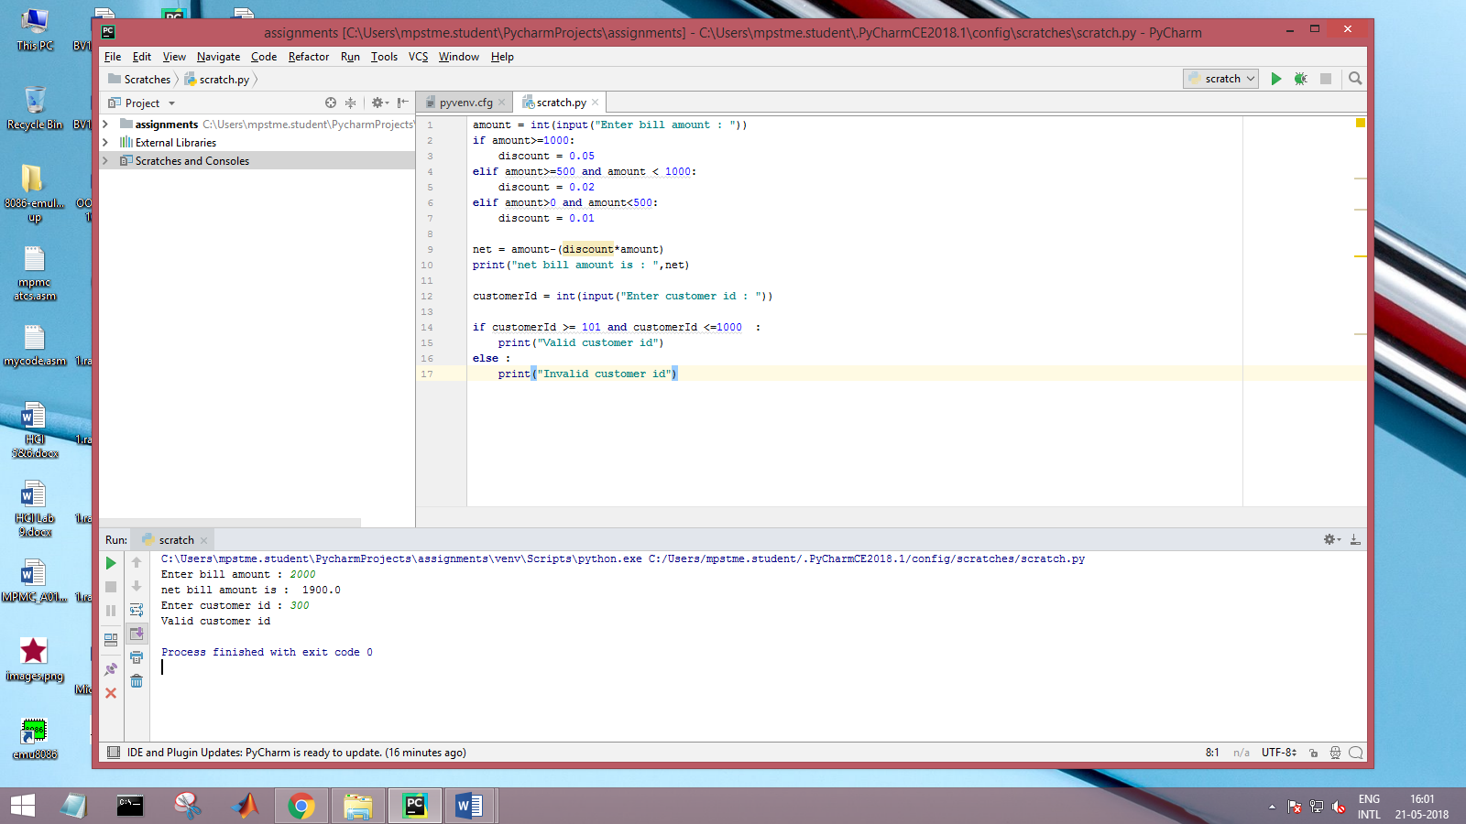

1. For invalid Customer Id

